**SPH3U: 1.3 Acceleration**

1. **Acceleration and graphs**

|  |  |
| --- | --- |
| Acceleration: |  |
| velocity-time graph |  |
| position-time graph |  |

|  |  |  |
| --- | --- | --- |
| **Position-Time Graph** | **Type of Motion** | **Example** |
|  |  |  |
|  |  |  |
|  |  |  |
|  |  |  |

1. **Determining acceleration from a velocity-time graph**

|  |  |
| --- | --- |
| Average acceleration: |  |

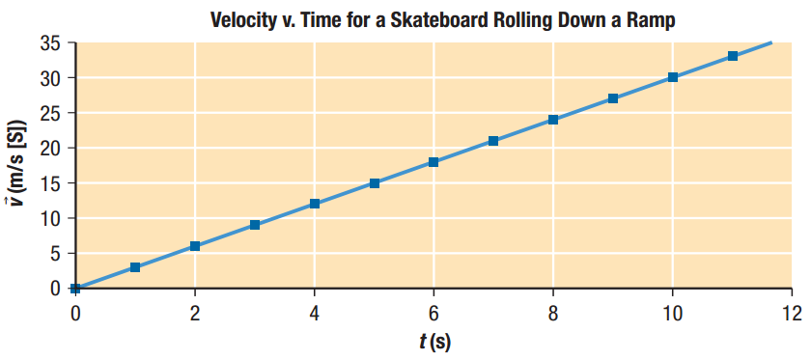

What is the acceleration of the skateboard in the figure above? Consider the motion between 0 s and 10 s.

When a rifle is fired, the rifle bullet accelerates from rest to 120 m/s [E] in 1.3 x 10-2 s as it travels down the rifle’s barrel. What is the bullet’s average acceleration?

When a hockey player hits a hockey puck with his stick, the velocity of the puck changes from 8.0 m/s [N] to 10.0 m/s [S] over a time interval of 0.050 s. What is the acceleration of the puck?

A racehorse takes 2.70 s to accelerate from a trot to a gallop. If the horse’s initial velocity is 3.61 m/s [W] and it experiences an acceleration of 2.77 m/s2 [W], what is the racehorse’s velocity when it gallops?

1. **Motion with uniform and non-uniform velocity**

|  |  |
| --- | --- |
| Area under a v-t graph: |  |

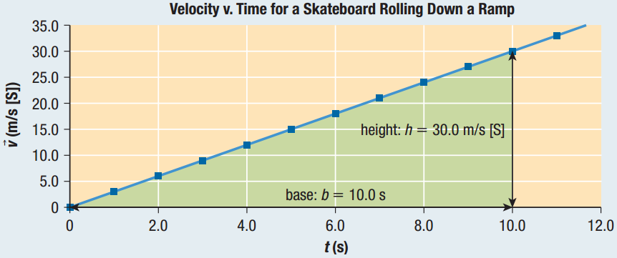

What is the displacement represented by the graph above?

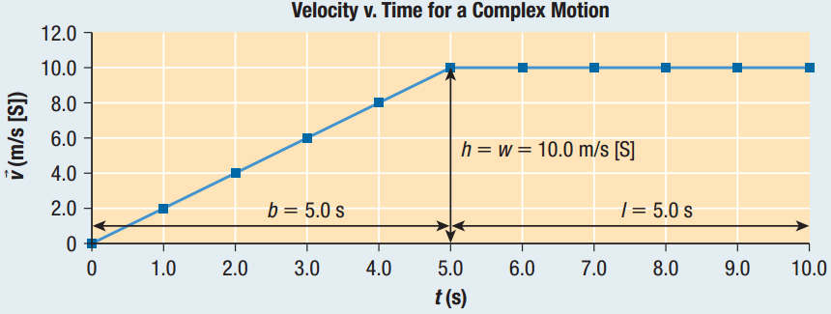What is the displacement represented by the graph below over the time interval from 0 s to 10.0 s?

1. **Instantaneous velocity and average velocity**

|  |  |
| --- | --- |
| Uniform acceleration: |  |
| average velocity |  |
| instantaneous velocity |  |
| tangent |  |

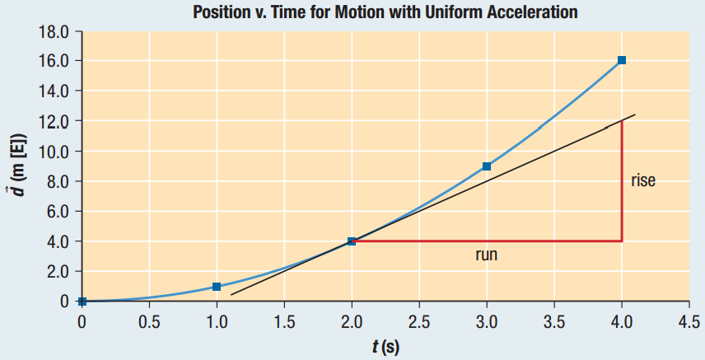

Consider the point on the curve in the figure above at 2.0 s on the ­*x*-axis. What is the instantaneous velocity of the object at this time?

What is the average velocity of the object in the figure above over the time interval from 0.0 s to 2.0 s?

**Homework:** page 30: #4-8, 11